Annex 4
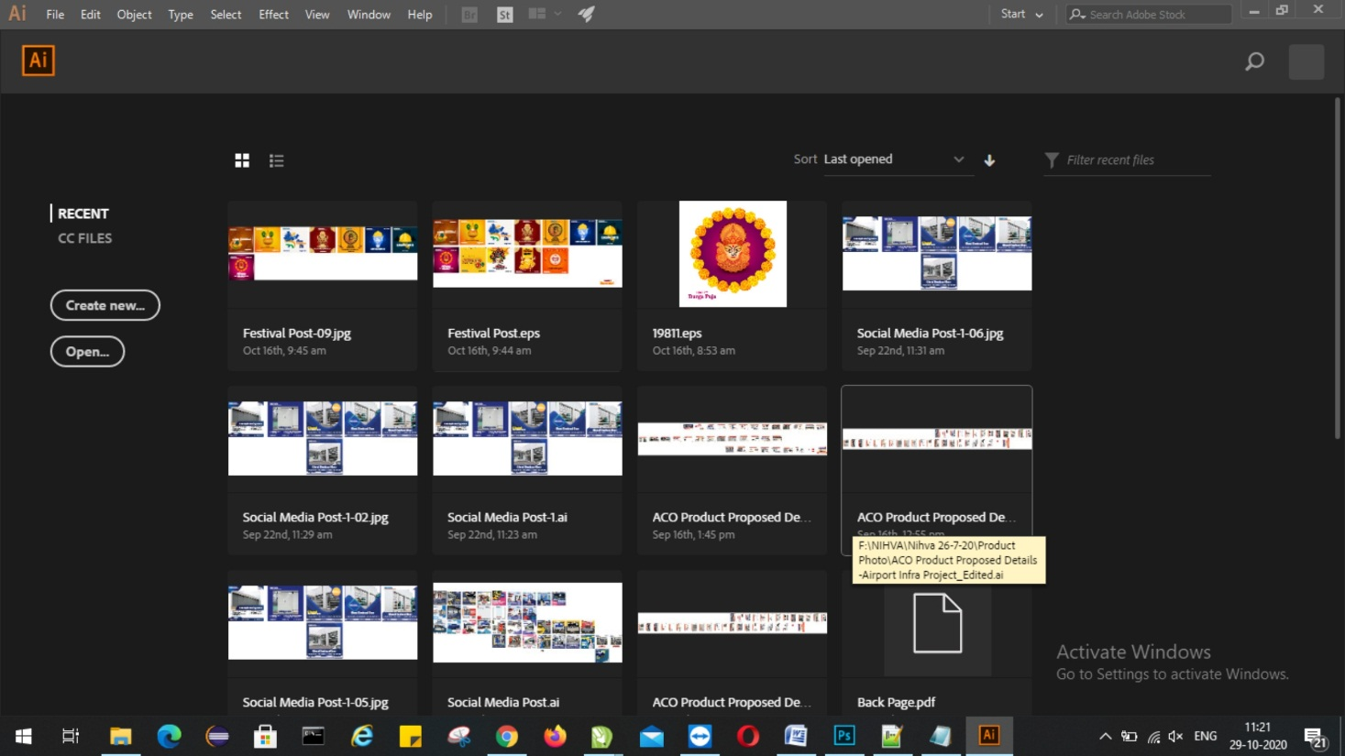
Screen captures of software-
Adobe Photoshop
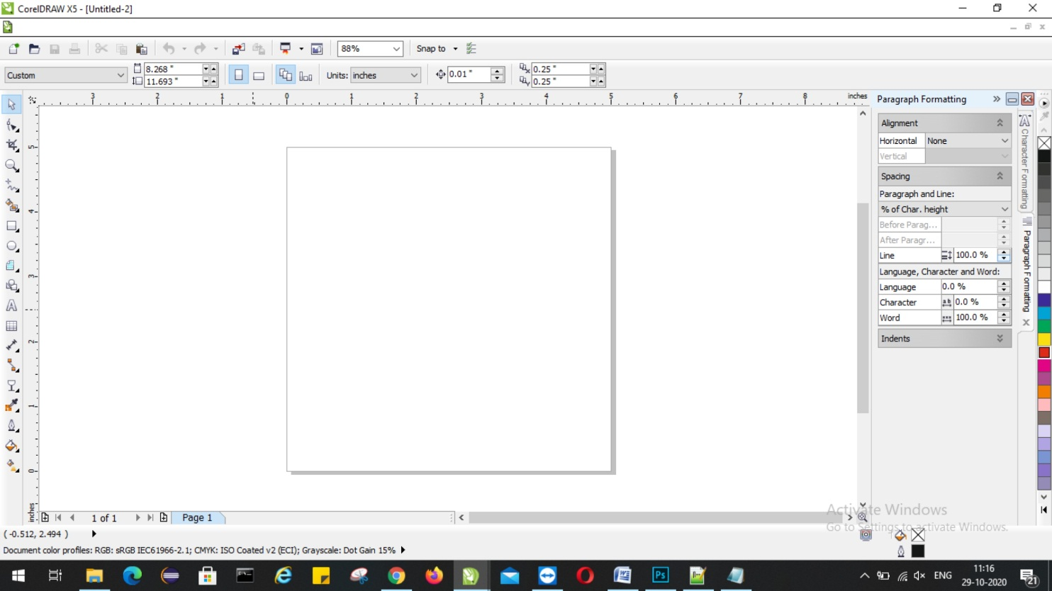
CorelDraw
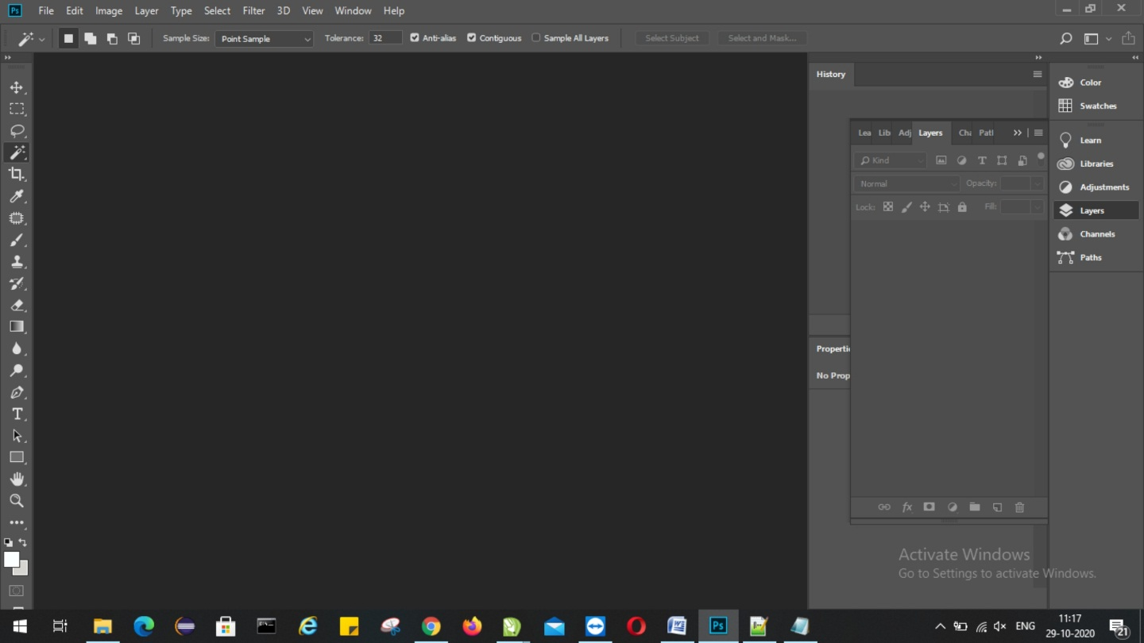

Adobe Illustrator

